4.27.20 8TH GRADE
Monday--- Here are your prompts for this week. Pick 4 out of 5. You will email your journals on Friday.
Journal Prompts
- How are you feeling today about your home and family life?
- How are you feeling about the world and how it has changed because of the pandemic?
- What do you miss the most about life from before this outbreak?
- What do you miss the least about life from before this outbreak?
- What changes do you think this pandemic has caused that will still be around years from now?
_________________________________________________________________
Tuesday---Final Exam for ELA
Please join the Chat on Tuesday at 1:30 for your Writing Prompt. You will receive the topic via Chat. You will have 10 minutes to organize your thoughts and 45 minutes to write. When you are finished, you will email your document to dcombs@stpatrickkc.com

Wednesday---Noredink
Here is your Noredink practice for the week. When you log in, you should see the following:
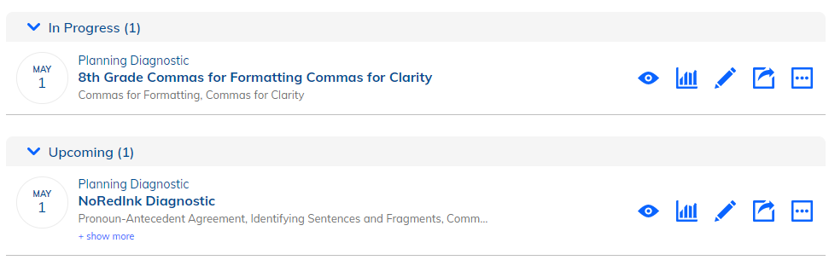
If you did not complete lasts weeks practice, you can still do so. Your new assignment is the Planning Diagnostic.

Thursday---Good News! Your Spelling AND Vocabulary are both in Spelling City. You do not have to go to Quizlet to complete vocabulary. Test Due May 1.
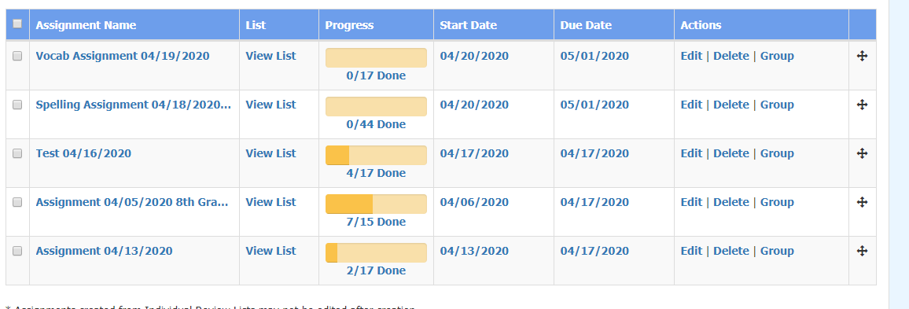

Friday--- Catch Up

